Social Media – Thank You

Thursday, Jan 16 – THANK YOU  Thank you, Federal employees and retirees! Your contributions during the 2024 @USOPM Combined Federal Campaign are making a difference in your community and around the world. Learn more @GiveCFC.org #GiveCFC | Thumbnail image provided for reference. Download the actual graphic/video from the Campaign worker Toolkit before posting.  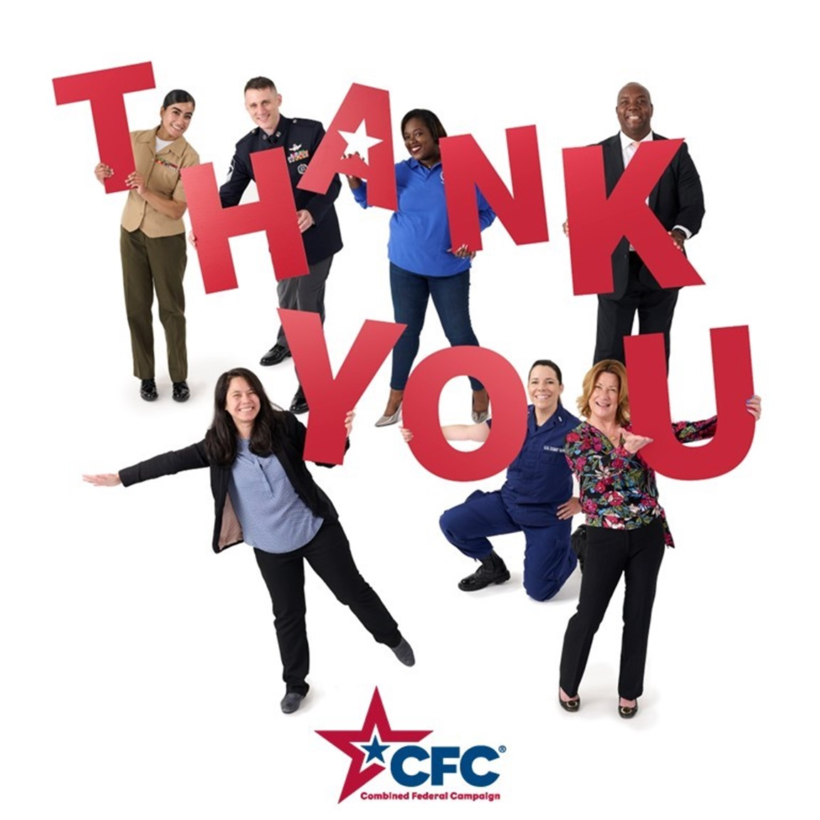 | ALT Text:  Thank you composite with CFC logo.
Monday, Jan 20- THANK YOU  We are thrilled to see the positive impact that the 2024 @USOPM CFC will have on so many deserving organizations! Your generosity is changing lives, and we are grateful for your support. Thank you for making a difference! #GiveCFC | Thumbnail image provided for reference. Download the actual graphic/video from the Campaign worker Toolkit before posting.  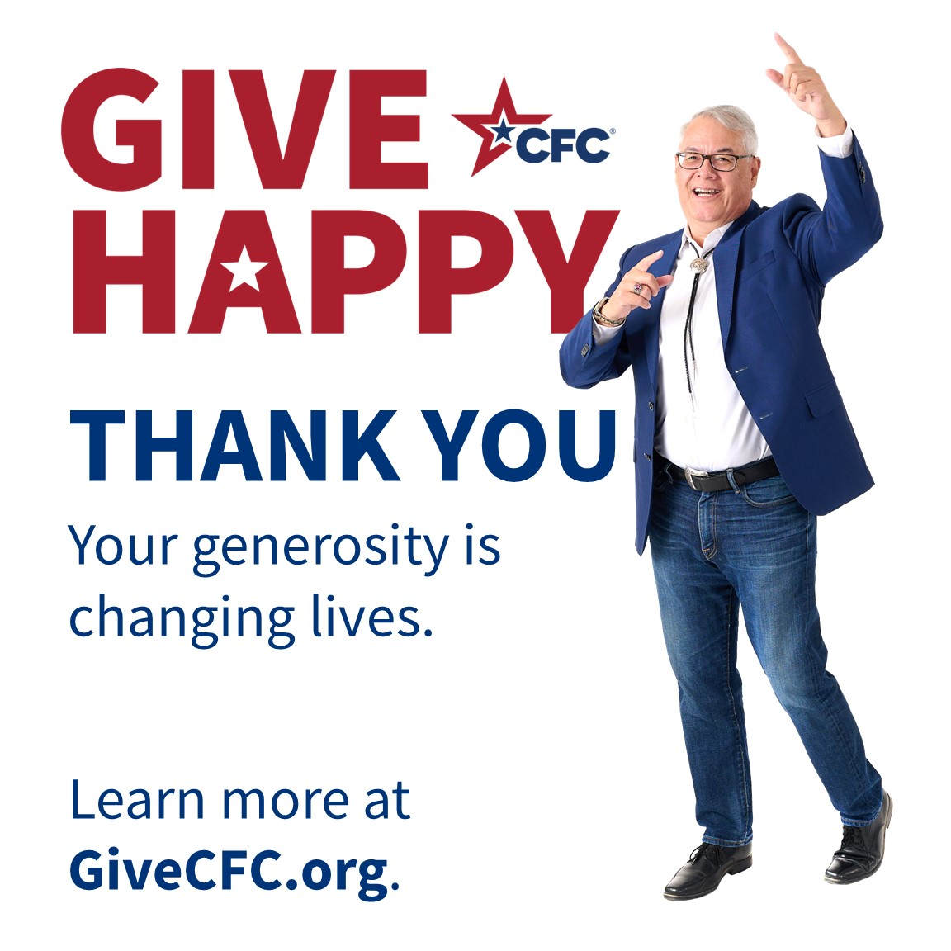 | ALT Text:  Man holding up arms with GVIE HAPPY logo.
Wednesday, Jan 22- THANK YOU  THANK YOU to all Federal employees! The donations made through @USOPM’s 2024 CFC are making a real difference in the lives of so many. Learn how these donations are making a difference at GiveCFC.org. #GiveCFC | Thumbnail image provided for reference. Download the actual graphic/video from the Campaign worker Toolkit before posting.   | ALT Text:  Red color block with uniformed man flexing muscles.
Thursday, Jan 30 – THANK YOU  THANK YOU for supporting CFC charities that support causes like treating and curing diseases, supporting military families, eradicating hunger, and making a positive difference in your community. Learn more how these gifts are making an impact at @USOPM’s GiveCFC.org. #GiveCFC | Thumbnail image provided for reference. Download the actual graphic/video from the Campaign worker Toolkit before posting.   | ALT Text:  Uniformed woman with GIVE HAPPY logo.

